Elie Herald
The Independent
Summer 2023
Editorial

We have fallen seriously behind our aspiration of quarterly newsletters for the village. To be frank, our enthusiasm was somewhat blunted after the last edition when objection was taken to one news item with a threat to take legal advice. Having crawled into our corner we have re-emerged perhaps chastened but nevertheless keen to keep the village informed of things that should concern it. For example, can we hope that more of the second homeowners and occasional visitors will take a more active interest in what is going on in the village and what needs to be done. Please let us know if you would like to help. The sesquicentenary (that’s 150th by the way) of the Thistle and Golf House Club is a momentous event for 2025 and it should not be allowed to pass without a village wide celebration. See article on this. We will no doubt have the usual problem of post barbeque beach litter, anti-social attitudes and behaviour, somewhat inebriated youths causing mayhem and thoughtless parking. We have already experienced a bad incident at the harbour where some youths set loose some boats and tormented a duck or two. This type of behaviour is unacceptable one would have thought but it still goes on. Please enjoy our facilities “responsibly”.

Elie Estate Developments

The following statement has been received from Elie Estates:

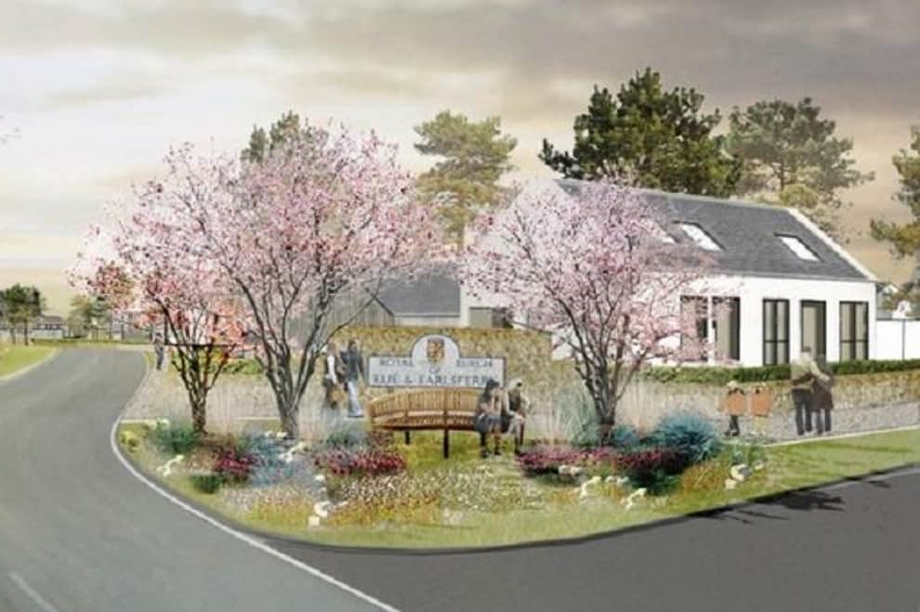
Planning Permission in Principle for the development sites at Wadeslea and the Grange was granted on 10th February 2023, having taken nearly five years to get through the planning system. Both applications were granted subject to a Section 75 Legal Agreement securing various planning obligations such as the provision and timing of affordable housing and a developer contribution to Fife Council of £1,000 per private residential unit for open space/play provision. Agreement has also been reached with Scottish Water and SEPA over upgrades to the sewage network and the foul water solutions for both Wadeslea and the Grange.

It is hoped that the Wadeslea development will provide 30 affordable homes offering a mix of tenures including social rent, mid-market rent and discounted sale. The social rented houses are expected to be offered by Kingdom Housing Association and members of the community interested in applying for one of these are encouraged to register their interest with KHA.

It is anticipated that a further 20 affordable homes will be put into a new Elie Housing Trust which will offer the houses either to rent on mid-market rents; or to buy on a discounted sale basis. The Housing Trust would be able to set an ‘allocations policy’ to give priority to local families, retirees from the local area and those with a connection to Elie but perhaps not able to afford to buy in the village. Elie Estate would be interested to hear from the community if there were other client groups that should be accounted for.

The discounted sale houses would be sold with a ‘rural housing burden’ which would sit on the title of the property in perpetuity. It would enable the purchaser to acquire the property at a discount to its market value but on the basis that the purchaser was one of the priority client groups; and subject to certain conditions such as that it was their sole residence, could not be rented out and when sold it must be offered back to the Housing Trust at the same discount to its market value as it was sold for.

The developers believe there is a limited market for a new care home in the village at the present time, which may be brought forward in subsequent phases of the development. Although permission has been granted for a block of 2.5 storey retirement apartments, it is anticipated that these will be retirement bungalows restricted to the over 55 demographic and designed with the elderly in mind.

Provisional terms have been agreed with a Fife-based developer for the Wadeslea site who hopes to submit a Reserved Matters application in the Autumn with an anticipated start date of Spring 2024. As Wadeslea is where the affordable housing and sewage network upgrades are to take place, the focus of attention is at Wadeslea with the 25 houses at the Grange coming later in 2024 (see ‘Soapbox’ later).

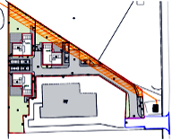
Whilst on the planning front, we had heard a rumour that the proposed small development at the telephone exchange may have been put on hold, but a recent application for variation of some house sizes suggests otherwise. We have the usual plethora of applications for extensions, etc. so white van man has a good income for many years to come from Elie and Earlsferry.
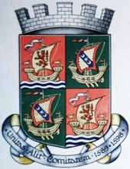
Elie & Earlsferry Community Council

Housing Crisis?

At a well-attended seminar organised and run by our MSP Willie Rennie in St. Andrews on 30th June there was much discussion about the “housing crisis” in the area. Initially, attention was paid to the St Andrews student accommodation problem and houses in multiple occupancy but in addition there was discussion about second homes and short term lets especially in the East Neuk.

There was also discussion about provision of new affordable housing and an impressive presentation from Community Housing Trust (CHT) (www.chtrust.co.uk). This charitable foundation, funded by Scottish Government, specialises in affordable houses and suitable infrastructure in rural areas and whilst previously associated with rural communities in the Highlands has now extended its interest to other rural communities.

Our community would fit into such a category. It works closely with communities to actively support repopulation and long-term sustainability. It takes a holistic view and a creative approach that looks beyond just housing; CHT works cooperatively with a wide range of public and private stakeholders to actively tackle repopulation and find viable solutions to the evolving challenges of community development in less well-served places. It builds houses and suitable infrastructure on which it imposes a “Rural Housing Burden” of two main elements:
- A percentage discount offers a discount to a purchaser from the open market value.
- A right of pre-emption giving the CHT the option to buy back the property when the owner decides to sell their home. This then allows CHT to sell the property to another purchaser in the local community provided the purchaser meets the criteria, and a discount will be applied to the market value for any future sales.

Further conditions state that the property must be used as a primary residence, and not let, as a way to restrict holiday- and second-home ownership.

This model might well suit developments in Elie see above. Presently the trust is working on such a scheme at Kingsbarns via the Cambo Estate.

The second aspect to come out of the conference was a suggestion by the Chair of our Community Council (and adopted enthusiastically by Willie Rennie) that more local consultation should take place with a view to tailoring the housing policy and needs to a particular area. In our view this would take into account the special needs of the holiday spots in the East Neuk and acknowledge the presence of so many second homes and rental properties. It will take time but any progress is better than none.

Community Council Elections

This year is the year for change in the community council. Any person who lives in and is on the electoral roll of Elie and Earlsferry is eligible to stand for membership of the local community council. Hitherto the reputation of the effectiveness of community councils has been in question but your community does need interested and enthusiastic citizens to manage such of the affairs of the area that are within its remit and also it acts as a conduit for local views to be expressed to Fife Council and its elected Councillors.

If you are interested in doing your bit this is what you have to do:

The elections will take place on Thu 28th Sep 23, on the assumption that more than 8 applications for election are made - otherwise the 8 or less are automatically elected. The deadline to apply to register to vote to be able to stand as a candidate is 10 Jul. Submission of nomination papers for election is 31 Aug. Publication of Statements as to Persons Nominated is 5 Sep.

Each candidate has to give a short analysis of what they think they could bring to the council.

The Community Council web page on Fife Council website has been updated to advise of the forthcoming election date - see website for details:
https://www.fife.gov.uk/kb/docs/articles/council-and-democracy/politicians-and-committees/community-councils
Nomination papers will be available from the Community Council’s page on fife.gov.uk from the 14th of August.
Anyone wishing to stand will require their electoral roll number, this can be found by contacting Election.Enquiries@fife.gov.uk The first meeting of the newly elected council will take place early in September.

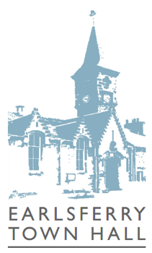
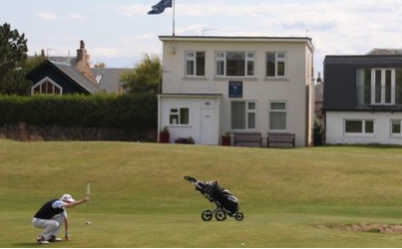
Earlsferry Town Hall The Town Hall is a traditional stone-built category 'B' listed building consisting of a main hall, two smaller meeting rooms and kitchen facilities. The main hall measures fourteen by eight metres has a raised stage and can accommodate up to 100 seated.

Located in the heart of Earlsferry, this iconic historical building, is ideally positioned to serve the local community, that of the surrounding areas and the many visitors to the East Neuk.

The Hall is available to hire for family anniversaries, celebrations, dances, community parties, exhibitions and commercial activities. It can also be booked by those in the community. For more information please visit earlsferrytownhall.co.uk

Community & Clubs
- Live music in the Hall
- Yoga Classes by Judith Dunlop
- Elie & Earlsferry Community Cinema
- Portraits of India Exhibition
- Summer Camp with Amy Knox
- Mahjong for Beginners. Thursdays 4.00-6.00pm
- Elie and Earlsferry Wine Club
- ETH Bridge Club continues Thursdays; meeting at 5.45pm prompt and commencing at 6.00pm (finish by 8.00pm).

We have received the kind promise of a second Table Tennis table and hope to have both up and running soon.

Want to know more about cinema screenings?

Details are at earlsferrytownhall.co.uk
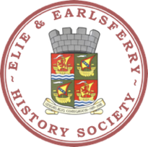
History Society

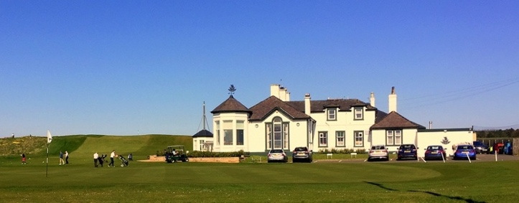
1875 was an extremely important year for development of golf and the golf course in Elie. It therefore makes 2025 an equally important milestone – sesquicentennial, apparently. In 1875 W.R. Ketchen and five or six other golfers in Elie and the surrounding district met together and formed the Golf House Club (GHC) with playing rights over the Melon Park per a lease granted by Baird, the owner of Elie Estate, to Ketchen and others. At the same time, perhaps mindful that there would be no room for the journeymen of Earlsferry in the “toffs” club, four members of the old Earlsferry and Elie Golf Club established the Earlsferry Thistle Golf Club, also with playing rights over the Earlsferry golfing tract and the Melon Park.

Within 10 years other land had been acquired by the Golf House Club to provide sufficient room for an 18 hole golf course and the rest is history. It is a history which needs serious celebration from not only both golf clubs but from the village as whole.

Had it not been for that initiative we would not have the fine golf course and with it the influx of tourists we now have and the resultant economic impact to the area. It would be tempting for GHC to go it alone with a celebration of this anniversary, but in our view this would be a mistake. The whole village has to be involved in this surely, to celebrate the anniversary of both golf clubs which have contributed so much to Elie and Earlsferry.

It may well be that there are committees currently considering this anniversary and we would urge them to consider some of the following points:

- A special event should be held in Earlsferry Town Hall to commemorate both anniversaries. The History Society may well be prepared to mount an exhibition and event.
- To also acknowledge the worldwide contribution of the golf club makers of Earlsferry - Forrester, Crowley and Scott.
- To celebrate the legacy of the forty young men from Earlsferry who became professional golfers pioneering the game mainly in the United States from 1880 to after the first world war.
- To also acknowledge and celebrate the contribution of two Open Golf champions from Earlsferry – Simpson and Braid (see www.eliehistory.com)
- To celebrate in general the development of Elie Golf Course, along with the historical significance of the litigation with the Malcolm family of the Grange Estate between 1812 and 1875.
The village should also get behind both clubs in their plans.

The March Stone?

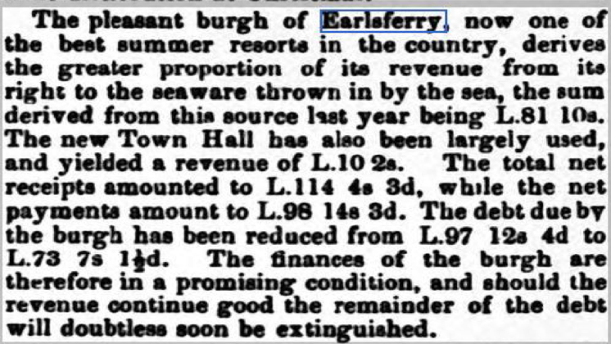
One of the privileges of being a Royal Burgh was that the administration of the burgh was entitled to rent out the “seaware” to bidders. See this from 1874:

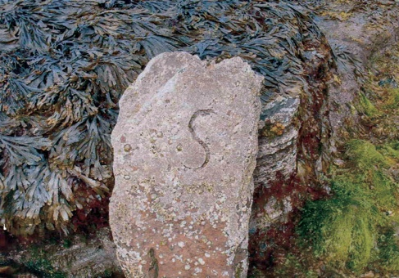
This was usually sand and seaweed for soil enhancement. The Royal Burgh of Earlsferry controlled that enterprise on Earlsferry Beach.
There is a stone obelisk visible at low tide immediately on the line of Ferry Road which shows the boundary between the two villages. Everything to the west is Earlsferry. The letter “S” is inscribed on this stone which is thought to face the south – but it doesn’t – we blame the tides and storms for turning it 180 degrees.

HMS Bellona

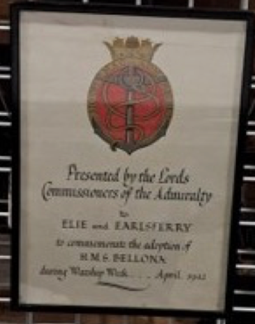
During the second world war to raise funds for the war effort villages and towns were invited to sponsor a warship. Fife sponsored HMS Bellona and there is a certificate to that effect addressed to Elie and Earlsferry currently held by Fife Council. We think it should be hung on the wall of the Earlsferry Town Hall and perhaps the Town Hall group could take this up.

HMS Bellona was a light cruiser, entering service in late 1943, the cruiser operated during World War II as an escort for the Arctic convoys, and as a jamming ship to prevent the use of radio-controlled bombs and in support of the Omaha Beach landings.

On 6 June Bellona's duty was to help to support Omaha Beach, in the American sector, where she was placed along with US battleships USS Texas and USS Arkansas under the command of Rear Admiral Carleton F. Bryant. As the army advanced, Bellona fired her guns inshore at targets spotted by aircraft and forward observation officers offshore.

In 1946 the cruiser was loaned to the Royal New Zealand Navy. Bellona was returned to the Royal Navy in 1956. She did not re-enter service and was scrapped two years later.

There is lots to explore on the History Society website - www.eliehistory.com
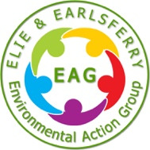
Environmental Action Group (EAG)

Please Help Keep Our Village Looking Good

The EAG works hard to maintain and enhance the village. The small, dedicated team of volunteers has ensured there are lots of planters and tubs to add colour and enrich the village. The team has also purchased new benches and picnic tables. We sweep, tidy, clean, plant, weed and water!

We need to raise money to fund not just the annual maintenance of plants, tubs and boats, but also to take on new projects, such as renewing benches, replacing planters, refurbishing the fountain, etc.

There are three ways you can make a donation:

- By BACS payment to:
E&E EAG Business Current Account
Account number: 00137431 Sort code: 83-15-08

- By cash or cheque (made payable to E&E EAG):

- Drop off at Westerlea, Links Place, Elie KY9 1AX

- Online at GoFundMe – just scan the QR code below.

Water Pump on Toll Green

We have a dilemma with the antique fountain at the corner of Toll Green. We have alluded to this in previous editions but now the fountain is desperately in need of major repair and refurbishment.

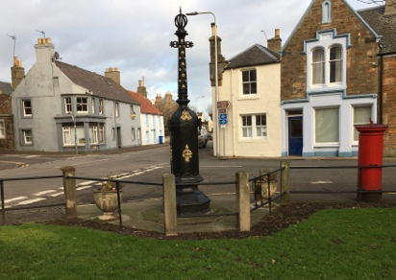
We have three problems: the first is obviously finance - estimates received indicate that professional refurbishment would cost in the region of £15–20k. Raising this kind of money will not be easy and will take time – meanwhile the fountain deteriorates further. Secondly, there is some doubt as to who actually has responsibility for the fountain. The history, briefly, is that it was a replacement for a previous water fountain that stood by the old Toll Booth at Toll Green and it was donated to the “the village” by the then Trustees of William Baird in about 1870 (William Baird (senior) who had bought the Elie estate in 1850s died in 1864). Paperwork of course does not exist, but newspaper reports make this suggestion. So perhaps Fife Council, as successors, are the owners and have responsibility for it. It seems most unlikely that Fife Council would consider taking the lead on refurbishment, given the cost.

This is likely to be very much in our own hands. It would be ideal, but perhaps a little speculative, to think that in addition to refurbishment the fountain could be connected to the water system and brought back into use. We are already on the waiting list for a water Top Up Tap from Scottish Water. The third and currently more pressing matter is its interim preservation. Some metal repairs are needed urgently and delaying them will lead to further deterioration (the History Society has already paid for replacement of the finial on the top). Should we just give it an interim lick of paint and keep doing that every so often? Certainly this is possible and the EAG and History Society would be happy to take this on. But there is the hurdle of planning permission to overcome, which is best dealt with the Community Council, who will hopefully take the lead with this project.

Whilst we are on about Toll Green, investigations have found that to replace all the trees, currently inhabited and infested by rather aggressive and noisy birds, with ornamental trees of a less accommodating nature would cost in the region of £7000. This is beyond budget at the moment so the only interim solution would be to trim the trees and replace on an on-going basis any dead trees with the more ornamental and less accommodating variety. It is hoped that Fife Council have that in hand, but of course we have to wait until the birds leave their nests.

The group is always looking for new recruits to help and to provide ideas for improving our village.
Contact us at: elieearlsferry@gmail.com

Toll Green Hall

Formally a neglected church property, the hall has been transformed by Amber Yard Interiors into a luxury intimate venue. Our aim is to provide a space for hire to benefit the residents of and visitors to Elie & Earlsferry by supporting cultural, educational, historical and health activities and events that bring local residents together.

The hall is available to rent by the hour, half or full day. It seats 28 over 6 tables or 40 standing.
There is a domestic kitchen and toilet.
Please note that there are no baby changing facilities and the narrow door may restrict mobility access.
The sphere symbol used in our logo is inspired by the Category C listed water pump which marks the entrance to the village green.

For more information on prices and how to book please contact tollgreenhall.co.uk

Playpark Group

The playpark facilities at Woodside are long overdue for an upgrade and refurbishment. As usual the question of cost become paramount. Fife Council has estimated that some £70k will be required to bring it up to a good standard and that is £70k which Fife Council does not have. Some enterprising parents of past and present children of the school have joined together to form a subgroup of the community council looking to raise funds for this project.

The new park will benefit all homeowners in the village and holidaymakers alike. Please continue to be so generous and invest in this upgrade for the village.

For anyone who would like to donate or help with fundraising please contact Bridget at:
missbmcguire@gmail.com
Church Services

Sunday 1000hrs Sunday Refreshment
1030hrs Traditional Sunday Worship:
- 1st & 3rd Sundays of the month – Elie Church
- 2nd & 4th Sundays – Kilconquhar Church
- 5th Sunday – Colinsburgh Community Hall

The link to the current ENT Church newsletter is via the website along with all other information.

Contact us at: eastneuktrinity.co.uk

Elie Harbour Trust
The Elie Harbour Trust is a charity managed by 12 Trustees who work to improve the Harbour and make it as safe and functional as possible to a wide range of users. Significant investment has been made this year in repairing and improving the harbour.

The Harbour is also home to Elie & Earlsferry Sailing Club and Elie Watersports, providing water-based activities to boat owners, visitors and tourists. It is a Seaside Award Beach. If you are interested in either
applying for a mooring or using the Harbour as a venue please contact us at:

www.elieharbourtrust.org.uk

Sports’ Section

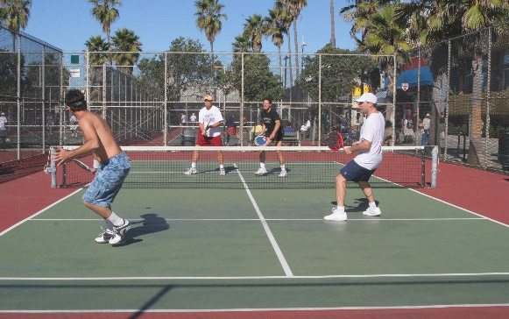
The Sports’ Club has applied for planning permission to create four paddle tennis courts. Paddle tennis seems to be all the up and coming rage for those just agile enough to jump around a little. Frankly, we have never understood how the tennis players can hit the ball so hard and yet it lands in the court. Every time we hit it that hard it finished in the bowling green! Anyway, this could well be a good facility for the aspiring but aging tennis player who finds the present court area too big to cover in a couple of strides.
Soapbox
For many years it has seemed that there was a sort of tension between the local population of the villages and the incomers (usually second home owners). In more recent times the pre-domination of the second home owners has resulted in a feeling of slight inferiority for those who live full time in the village and in most cases are more concerned about the physical well being and tidiness of the place. The week ender seems to parachute in, enjoy the facilities and parachutes out on the Sunday leaving the permanent residents to clear up any mess. Of course it is not as extreme as that, but there is a feeling at times of resentment that the second home owners and short time renters do not contribute in any way to keeping the village spick and span. This has a number of consequences - not least the price of property. In our view there is nothing that can be done to change this ethos other than make more homes available to permanent residents and at a cost that they can afford. Elie Estate’s plans are hopefully in the right direction. It seems to us this could be achieved by projecting what a two child family of middle management might find more attractive to live here, than a modern estate in the outskirts of Edinburgh or Glasgow. High on the agenda would be a transport infrastructure (road and rail) which would enable that breadwinners to commute speedily to the main conurbations and add to that superfast broad band speed enabling home working. But this needs affordable housing of whatever sort. The extension of the railway to Levenmouth makes the main conurbations closer but still not sufficiently close for the “three days a week” say commuter. It used to be the case that you could board a train in Elie at 8 am and be in Edinburgh or Glasgow by 9.15. Would that not be attractive to the middle manager? A better road infrastructure would help even if it is only to get to the nearest rail station which Google thinks is North Berwick! So what do we need houses, houses, houses. The mix has to be affordable housing, mid market rentals, Rural Housing Burden (see Community Housing Trust supra). That’s the need but at the same time it must not change the environment which attracts so many holiday makers and second home owners. We think this could be done by building on the periphery of the villages. That certainly was Elie Estates pragmatic solution.
The Elie Herald is a free publication;
however, we welcome donations. Any surplus after production costs is donated to local groups. We are also grateful to a local business for providing the paper and printing facilities.

The views expressed are solely those of the author. Edited by Graham Johnston.
Design & layout by Graham Meacher.
If you have any feedback, contributions or some news to share you can contact us at:
elieearlsferry@gmail.com

